Important parameter list:
- –sd: the file path; (it is the file direction about the dataset)
- –sn: the file of features;
- –sf: the source file;
- –tf: the test file;
- –ulr: the ratio of unlabeled data (for example: -ulr 0.1 means 10% unlabeled data. In fact, it is an approximate value in the experiments);
- –bi: whether output the results incrementally. 1: yes, 0: no
- –in: the instance interval in the incremental output
- other parameters using the default settings as the following example.

The command line without incremental output (it is written in the file of “SSEMUI.bat”) is as follows.
Example A: for SEA
SRDTSystem-10-04-04 SSEMUI -sd F: \sea-recurring-concepts\interval-2k-10 -sn sea -sf integration-interval-50k -tf sea-2 -tc 1 -nm 200 -bcs 0 -minthres 5 -cp 200 -bhs 0 -bc 1 -tn 1 -bat 1 -minw 100 -maxw 10000 -rvc 0.5 -coe 0 -mintheta 0.2 -clusway 1 -ulr 0.1

Example B: for HyperPlane
SRDTSystem SSEMUI -sd F:\hyper\hyper-10-attr-2-change-0.004-interval=10k -sn HyperPlane -sf HyperPlaneTrain -tf HyperPlane -tc 1 -nm 200 -bcs 0 -minthres 5 -cp 200 -bhs 1 -bc 1 -tn 1 -bat 1 -minw 100 -maxw 10000 -rvc 0.5 -coe 0 -mintheta 0.2 -clusway 1 -ulr 0.1

Example C: For Elec
SRDTSystem SSEMUI -sd F: \elec2\processed -sn elec2-filter-3 -sf elec-year-sort-data-filter-10-times -tf elec-year-sort-filter -tc 1 -nm 200 -bcs 0 -minthres 5 -cp 200 -bhs 0 -bc 1 -tn 1 -bat 1 -minw 100 -maxw 10000 -rvc 0.5 -coe 0 -mintheta 0.2 -clusway 1 -ulr 0.1

Descriptions for output files:
- **.SSEMUI-Major-0-label-check: this file contains the labeling result.
Open this file, compute the statistics about the numbers of “||true “(denoted as tr) and “||false”(denoted fa),
Labeling accuracy = tr/tr+fa;
- **.SSEMUI-Major-0classifying: this file contains the classification result on the specified test file.
- **.SSEMUIMajorTest0: this file contains the classification result on the specified test data.

The command line with the incremental output is as follows.
Example A: for SEA
SRDTSystem-10-04-04 SSEMUI -sd F:\E\lpp-database\sea-recurring-concepts\interval-2k-10 -sn sea -sf integration-interval-50k -tf sea-2 -tc 1 -nm 200 -bcs 0 -minthres 5 -cp 200 -bhs 0 -bc 1 -tn 1 -bat 1 -minw 100 -maxw 10000 -rvc 0.5 -coe 0 -mintheta 0.2 -clusway 1 -ulr 0.1 –bi 1 –in 1000

Example B: for HyperPlane
SRDTSystem SSEMUI -sd F:\D\lpp-new-2009\database\hyper\hyper-10-attr-2-change-0.004-interval=10k -sn HyperPlane -sf HyperPlaneTrain -tf HyperPlane -tc 1 -nm 200 -bcs 0 -minthres 5 -cp 200 -bhs 1 -bc 1 -tn 1 -bat 1 -minw 100 -maxw 10000 -rvc 0.5 -coe 0 -mintheta 0.2 -clusway 1 -ulr 0.1 –bi 1 –in 1000

Example C: For Elec
SRDTSystem SSEMUI -sd F:\E\lpp-database\elec2\processed -sn elec2-filter-3 -sf elec-year-sort-data-filter-10-times -tf elec-year-sort-filter -tc 1 -nm 200 -bcs 0 -minthres 5 -cp 200 -bhs 0 -bc 1 -tn 1 -bat 1 -minw 100 -maxw 10000 -rvc 0.5 -coe 0 -mintheta 0.2 –clusway -ulr 0.1 –bi 1 –in 1000

Descriptions for other output files:
- **.SSEMUI-Major-0-Incre-result: this file contains the experimental results with incremental output.
You should find the string “||totalErrorRate =”, i.e., the corresponding total classification error rate. (as shown in Figure 8、10、12 in our paper);
You should find the string “|| error-rate /1000 =”, i.e., the corresponding incremental classification error rate. (as shown in Figure 7、9、11 in our paper)

executable-file.rar: contains the batch file, .exe, and elec databases with the feature file(**.names), training file(**.data) and test file (**.test)

How to run: double press the file of “SSEMUI.bat” and you can enter into the following interface:

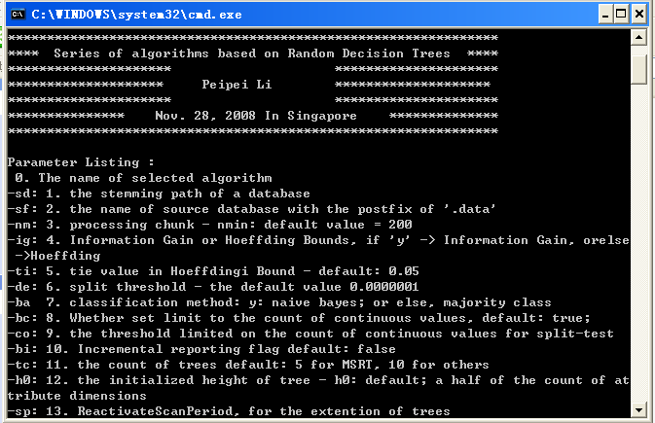
REDLLA is coded in VC++ in the operation system of miscrosoft windows xp.
note: All databases with at most 5% noise data are used in our experiments.

